Student Management API Implementation

Day 3KT task Implementation Document

College Name: Velammal Institute of Technology

College Code: 1133

Your Name : Karanam Rupesh

Department: Artificial intelligence and data science

Naan Mudhalvan (NM) ID: aut113323aib21

Phone Number: 9100872996

Email ID: karanamrupesh2005@gmail.com

Project Overview

Built a RESTful API for student management system using Node.js and Express.js. The API handles all CRUD operations with both single and bulk processing capabilities.

Implementation Steps

1. Project Setup
Created Node.js project with express.js framework
Set up basic folder structure
Installed required dependencies

2. File Structure Created
`index.js` Main server file
`routers/studentRouters.js` All student routes
`package.json` Project configuration
`.gitignore` Git exclusion file

3. Main Server Implementation
Configured Express server on port 3000
Added JSON middleware for request parsing
Set up route for student management
Added basic health check endpoint

4. Student RouteFeatures
READ Operations:
GET endpoint to retrieve all students

CREATE Operations:
POST endpoint for single student creation
POST bulk endpoint for multiple students
Input validation and duplicate checking

UPDATE Operations:
PUT endpoint for single student update
PUT endpoint for multiple student updates
Partial update support

DELETE Operations:
DELETE endpoint for single student removal
DELETE endpoint for multiple student removal

5. Key Features
Inmemory data storage using arrays
Complete error handling with status codes
Data validation for all inputs
Support for both single and bulk operations
RESTful API design principles

6. Testing
Tested all endpoints using API testing tools
Verified CRUD operations work correctly
Confirmed bulk operations handle partial failures

OUTPUT FINDINGS :

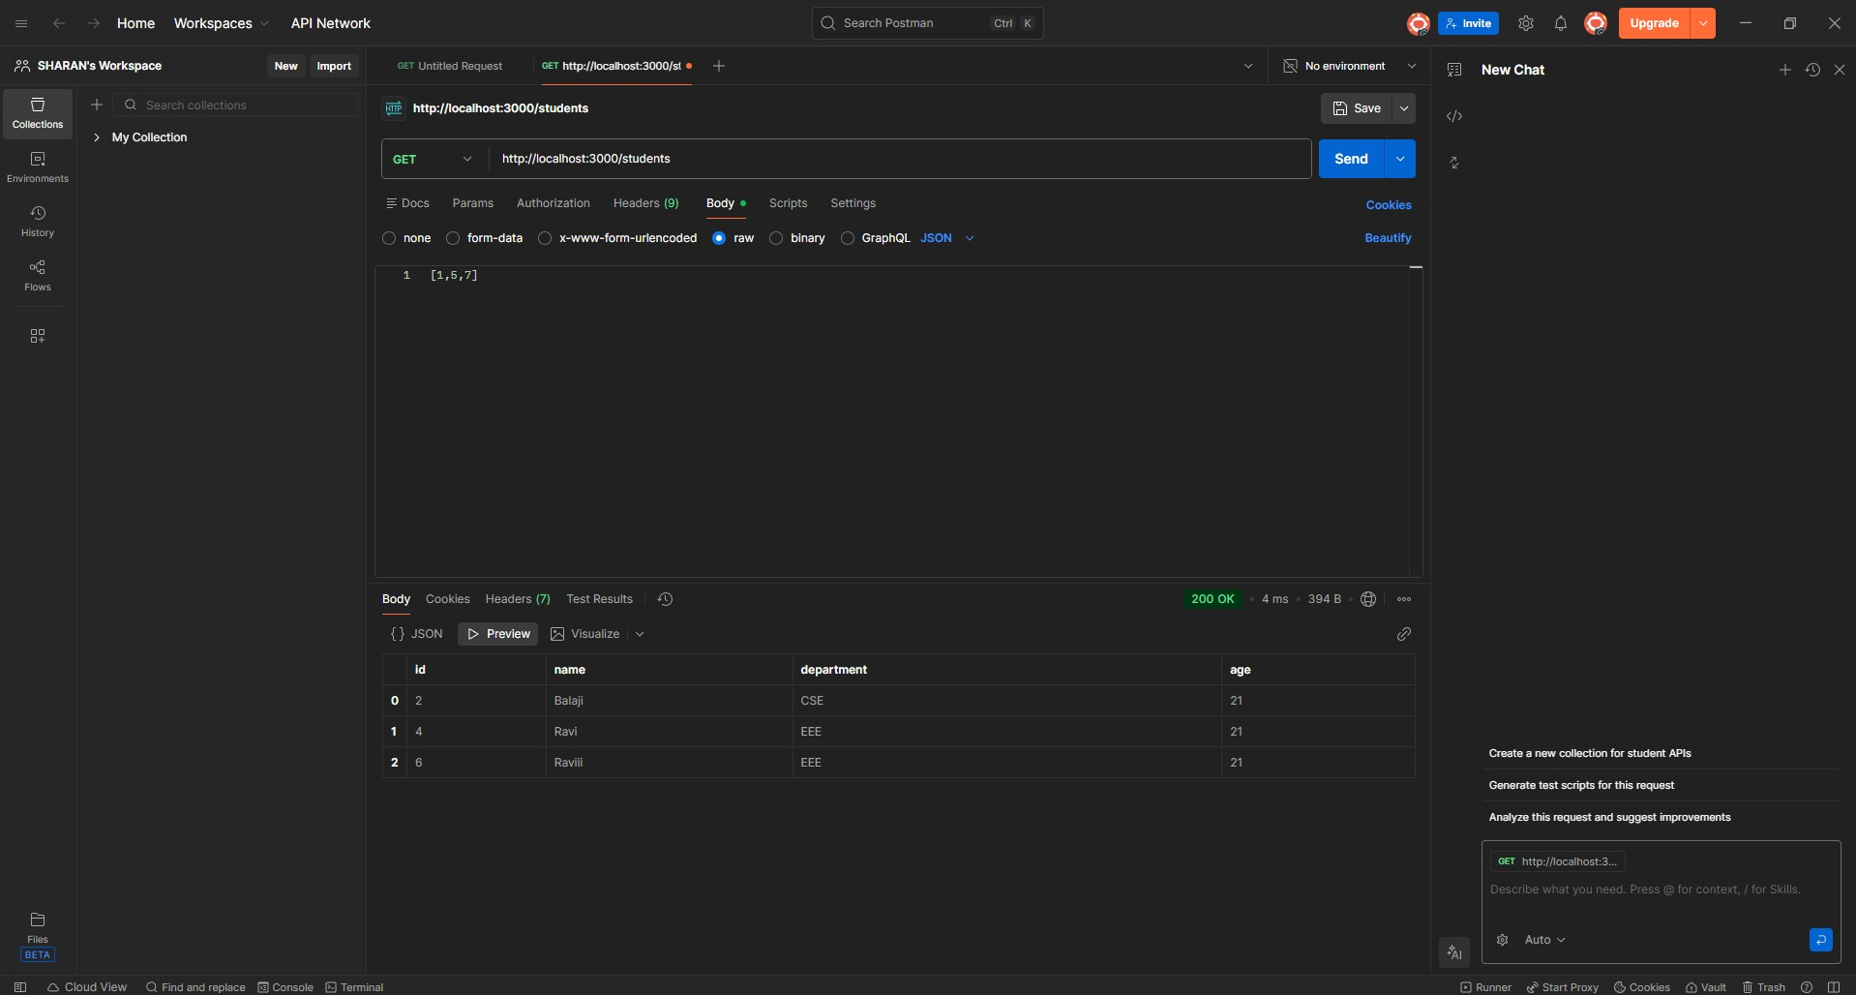

7. Documentation
Created comprehensive API documentation
Added code comments for clarity
Prepared this implementation report

What I Learned
- Building RESTful APIs with Express.js
- Implementing CRUD operations
- Handling bulk data operations
- Proper error handling in APIs
- Working within memory data storage

Challenges Solved
Implemented partial success handling for bulk operations
Created efficient array manipulation for data management
Designed clear API response formats

Files Submitted
- Complete source code in GitHub repository
- This implementation document
- All project configuration files

GITHUB :

